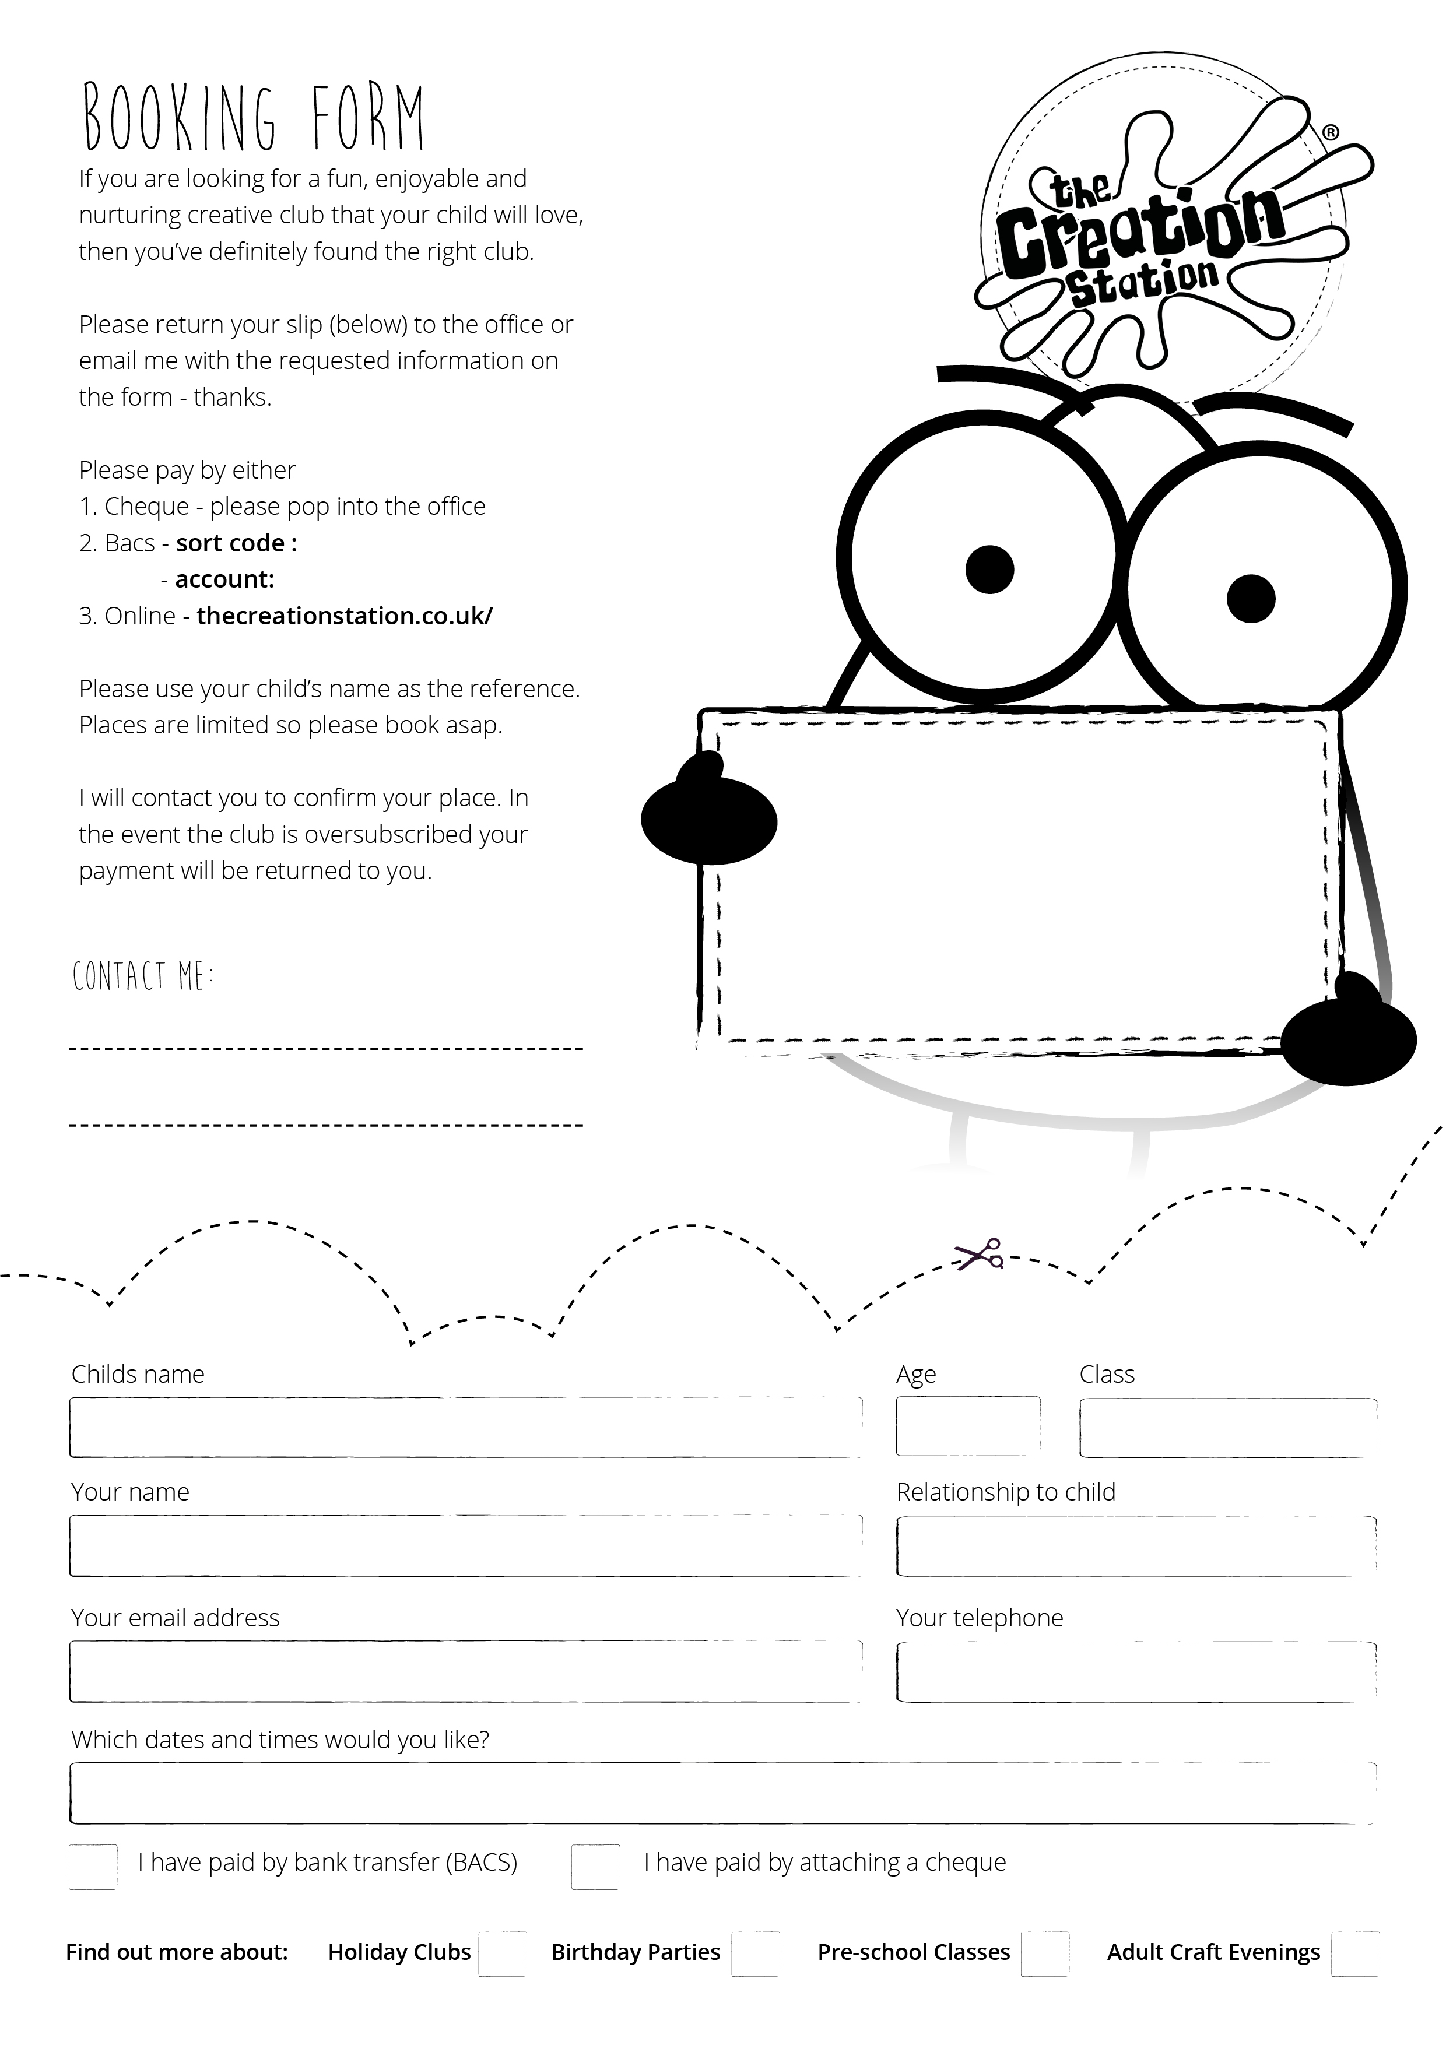

Tel 07745346391

Email kirstyhickson@thecreationstation.co.uk

Starts back at

Northfield Infants School

Thursday 13th January

Half term Cost £39

Full Term Cost £78

finder?location=yo25

40142647

60-07-05