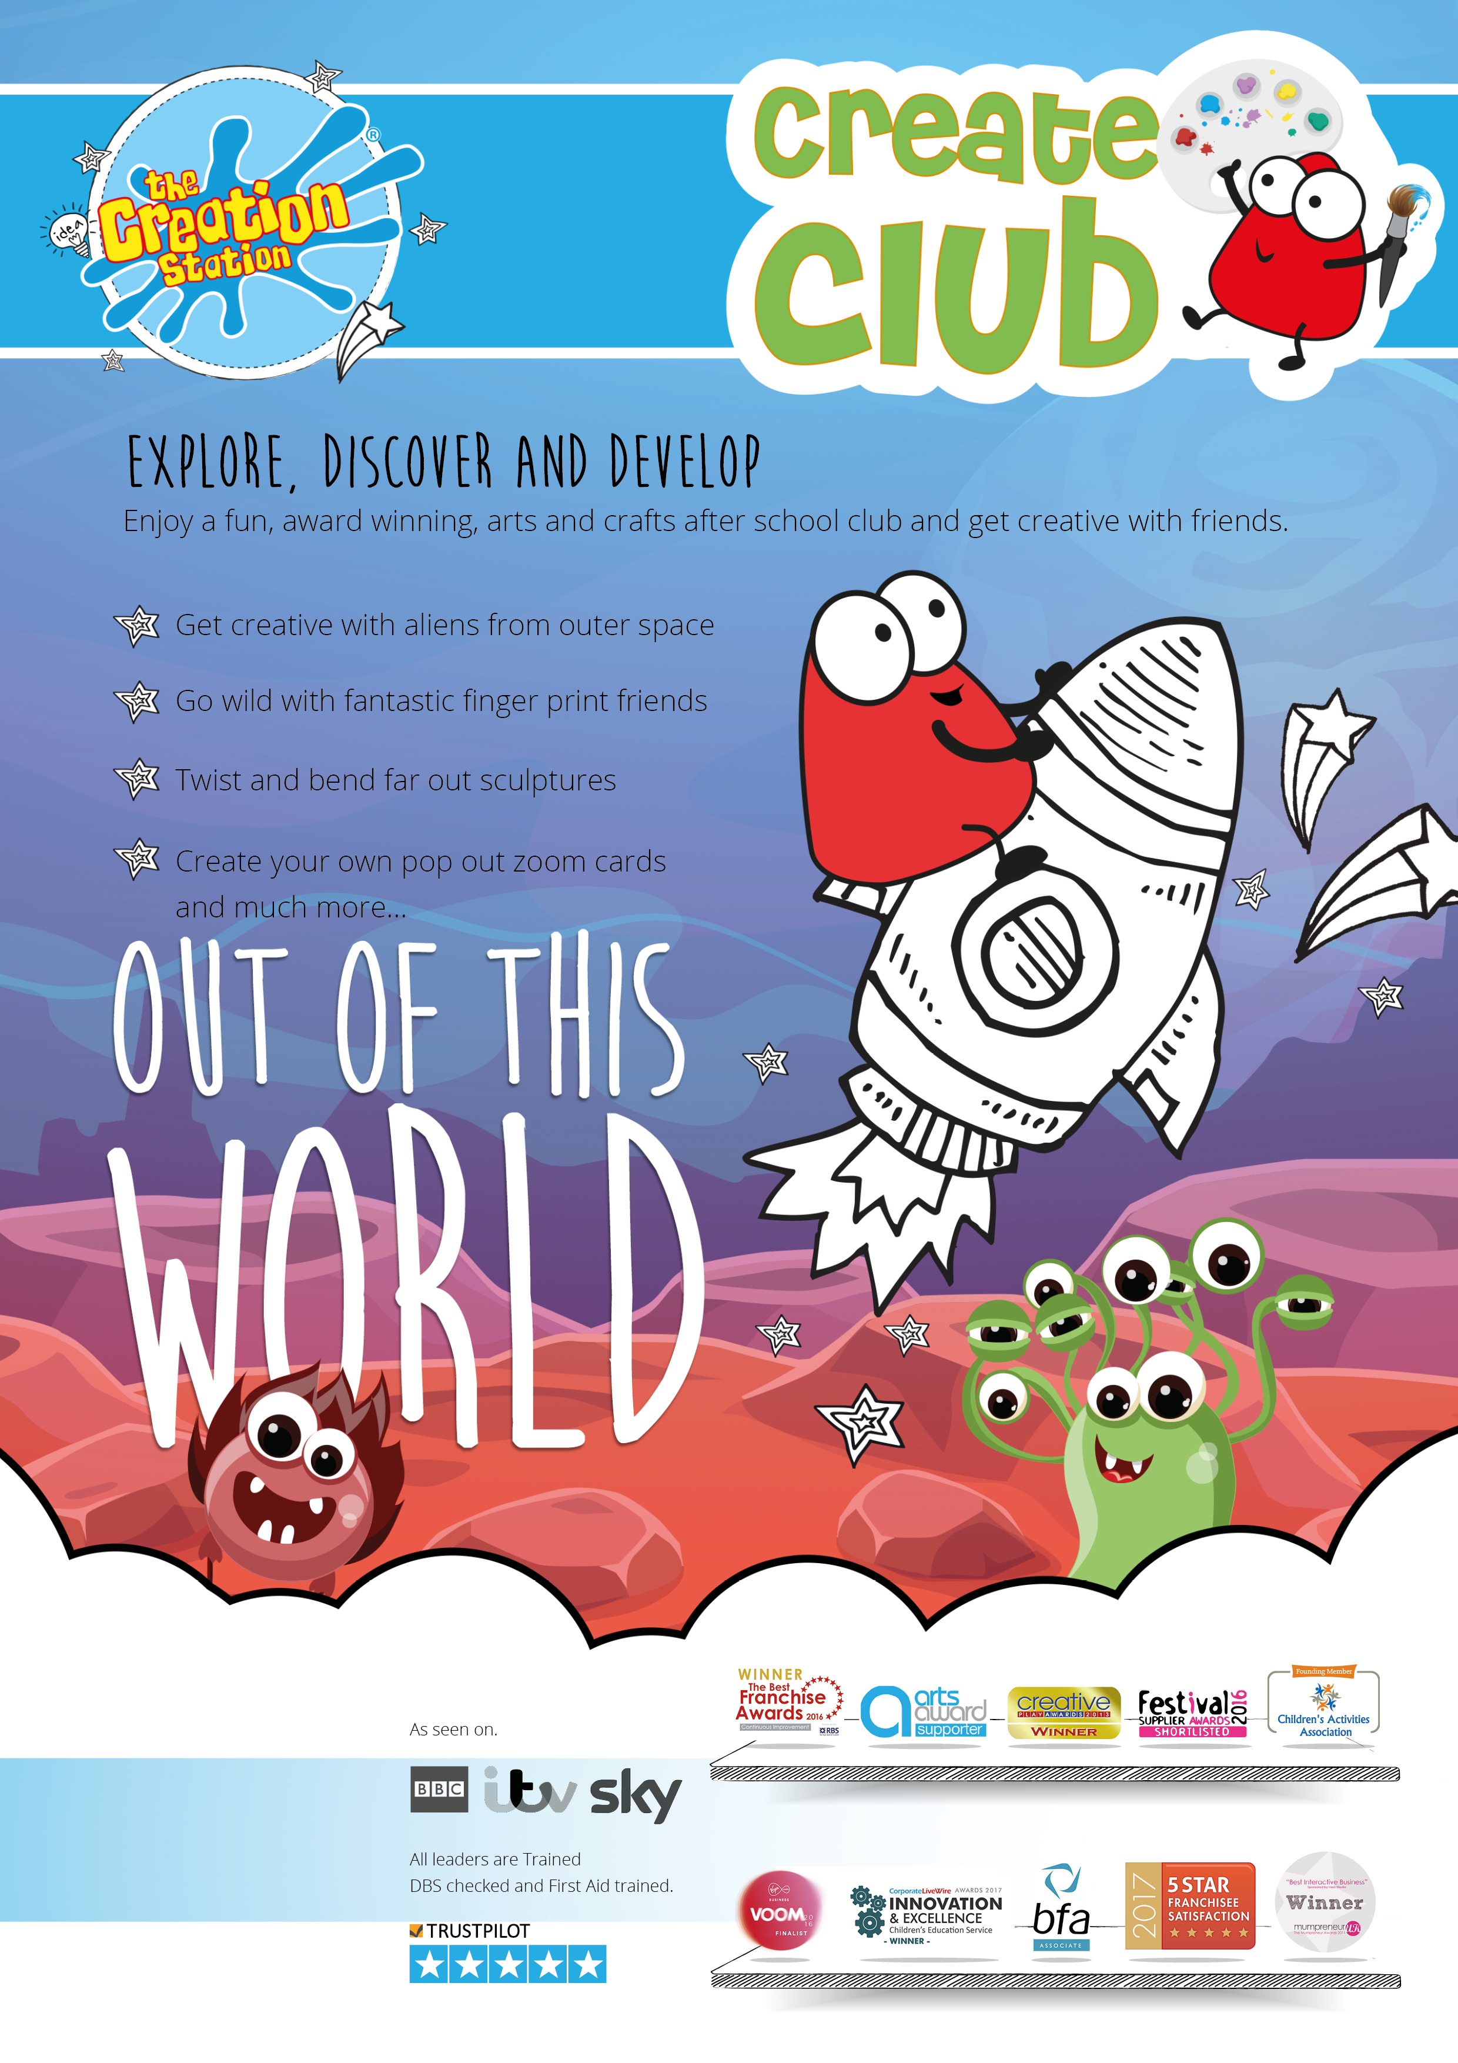

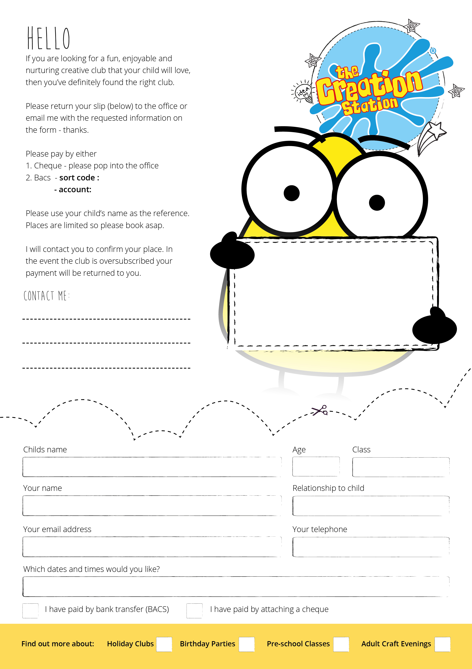

[kirstyhickson@thecreationstation.co.uk](mailto:kirstyhickson@thecreationstation.co.uk)

07745346391

Payment can be Cash at the first session,

BACS to

Natwest

Sort Code 60-07-05

Account Number 40142647

Please leave your childs name and school as a reference.

Or payment via the website.

Cash at the first session

Booking Via the Website

Thursday’s 3.20pm until 4.20pm

Northfield Infants

Half Term Price £39 Full TerM Price £78

Monthly payment available via the website.

40142647

60-07-05