Headteacher  Mrs. S.C. Woolhouse. B.Ed.Hons.  Tel: 01377 257487  Fax: 01377 272112  Email: northfield@eastriding.gov.uk |   ‘All Moving Forward Together’ | Driffield Northfield Infant School  Southfield Close  DRIFFIELD  East Yorkshire  YO25 5YN

17th January 2020

Dear Parents/Carers
As part of our learning in Science, about Living things and their habitats we would like to take the Year 2 children on a special trip to the Bempton Cliffs RSPB site and the Living Seas Centre at Flamborough. At the Bempton Cliffs nature reserve trained RSPB staff will introduce the children to the birds that live on the cliffs and the special habitat there. Children will have supervised access to binoculars and telescopes to observe a range of birds in their nests on the cliffs. At the Living Seas centre children will be introduced by trained staff from the Yorkshire Wildlife Trust, to a wide range of creatures that live on the shore.
The trip is booked for the 8th June and is in addition to the annual Year 2 trip to Sewerby Hall and Zoo in the summer term.
In order to keep the cost reasonable for parents we are asking the Year 2 children to undertake some fundraising activities to help with the cost of this trip. The fundraising activities will also help our children appreciate how much things cost and help them with their Maths when counting the money! The planned fundraising activities will include a danceathon, a crispy bun sale and an afternoon tea and cake sale. Details of these will follow nearer the time.
We are very fortunate to have such a fabulous natural resource so near. We thank you for your support to enable your children to appreciate the natural wonder on their doorstep.

Year 2 staff

 |  |  |  |  |  | 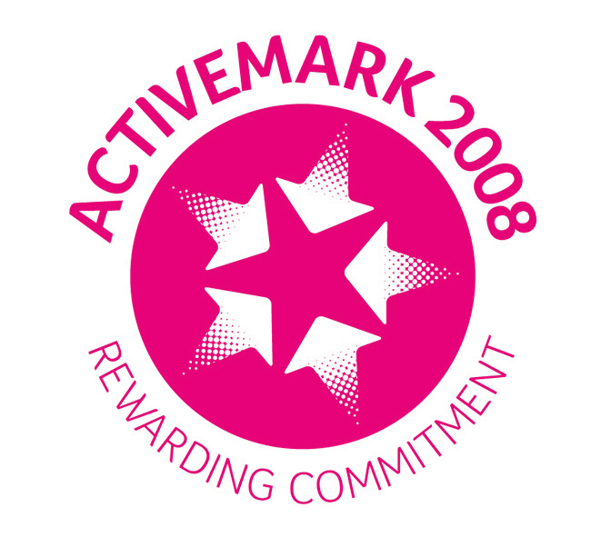

www.driffieldnorthfieldinfants.co.uk

